Hardware Specifications

Pinout
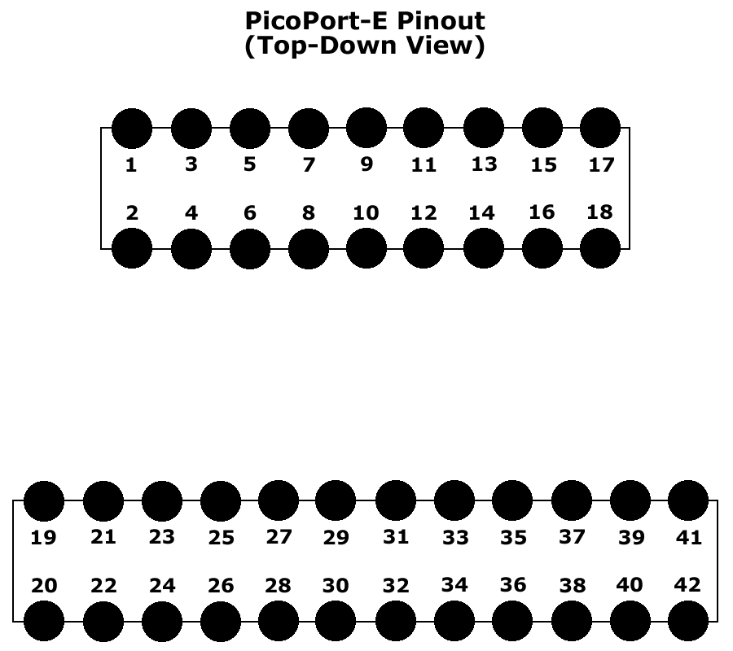

Pin | Function | Pin | Function
1 | NC (3.3V)¹ | 2 | GPIO_1
3 | RESET_N | 4 | GPIO_2
5 | USB_DP | 6 | GPIO_3
7 | USB_DM | 8 | GPIO_4
9 | USB_VBUS | 10 | GPIO_5
11 | NETWORK_RX  GPIO_10 | 12 | HOST_RX  SPI_MOSI  GPIO_6
13 | NETWORK_TX  GPIO_11 | 14 | HOST_TX  SPI_MISO  GPIO_7
15 | NETWORK_TXEN  GPIO_12 | 16 | HOST_TXEN  SPI_CS  GPIO_8
17 | GND | 18 | SPI_SCK  GPIO_9
19 | VCC (5V) | 20 | ETH0_LED_LINKACT
21 | MS_LED_GREEN | 22 | ETH0_CT
23 | MS_LED_RED | 24 | ETH0_RXP
25 | NS_LED_GREEN | 26 | ETH0_RXN
27 | NS_LED_RED | 28 | ETH0_TXP
29 | DIGITAL_IO_1 | 30 | ETH0_TXN
31 | DIGITAL_IO_2 | 32 | ETH1_LED_LINKACT
33 | USB_HOST_VBUS_EN | 34 | ETH1_CT
35 | USB_HOST_DP | 36 | ETH1_RXP
37 | USB_HOST_DM | 38 | ETH1_RXN
39 | USB_HOST_VBUS_IN | 40 | ETH1_TXP
41 | GND | 42 | ETH1_TXN

- Pin 1 is not used on the PicoPort-E, however, for compatibility with the PicoPort, this pin should be connected to 3.3V.

Header Interface
The module uses one 18-position (2x9) header and one 24-position (2x12) header with 2.00mm spacing and 3.20mm lead length (Samtec part #TMMH-109-01-F-DV and part #TMMH-112-01-F-DV).

